**Step by step GitHub login Process:-**

Step 1 :- **Open GitHub:** Go to github.com in your web browser.

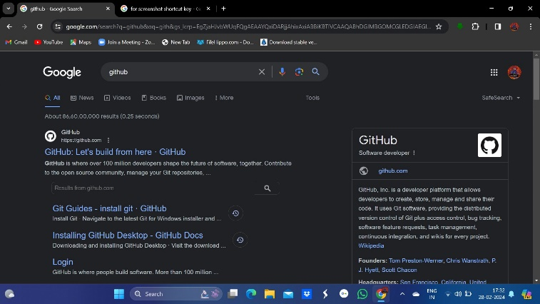

Step 2 :- **Click "Sign up":** You'll find this at the top right corner of the GitHub homepage..



Step 3 :- **Enter your email:**

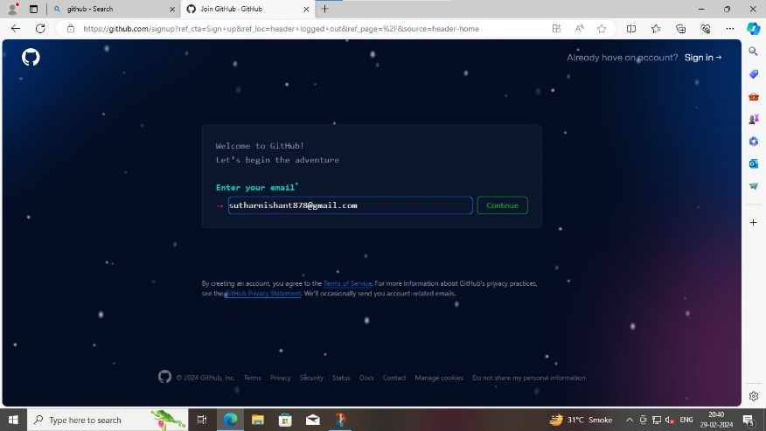

Step 3 **:Enter your username:**

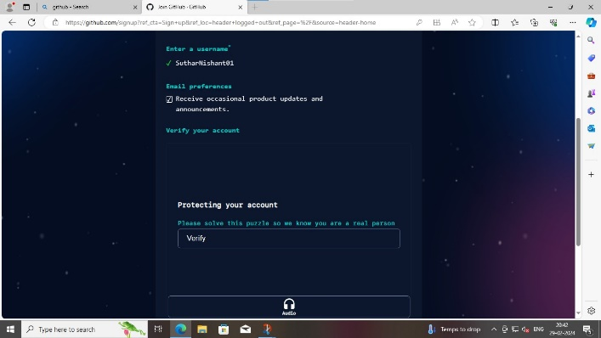

Step 5 :- **Varify your account:**

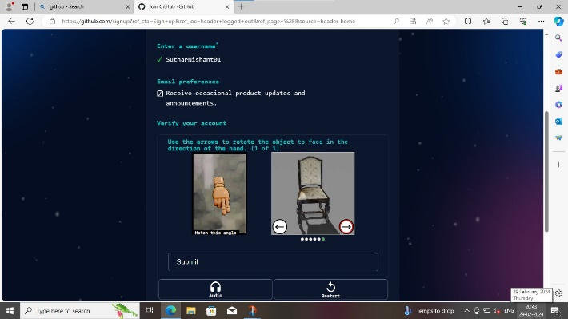

Step 6 :- **Access your account:** after create account, you’ll be redirected to your GitHub account dashboard.

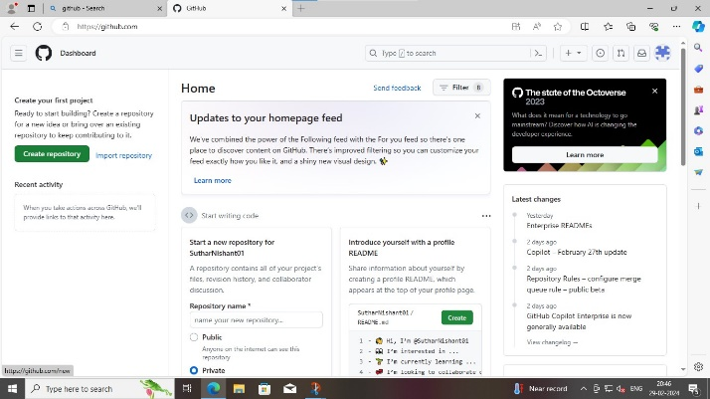

Step 7 :- **Create a new repository:**

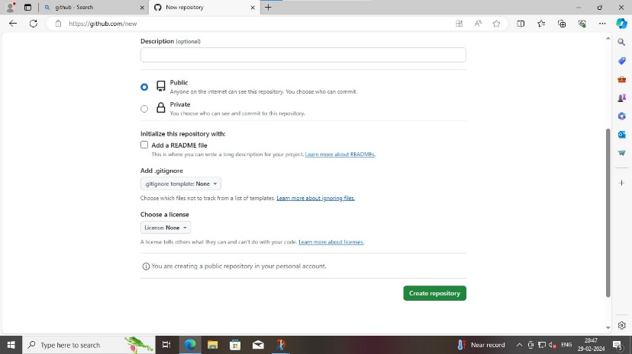

Step 8 :- **Here your repository created.**

